Admin initiates program frist time

Trigger Event: (0)

Event (0)

Wait for customer interaction



Trigger Event: (1)



Event: (1)

If before 1400 trigger Event: (2.1) else trigger Event: (2.2)

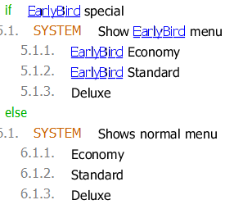

Early bird price event/

Event :(2.1)

Standard price event/

Event :(2.2)



Event: (2.1) Event (2.2)

Early econ Econ

Early standard Standard

Deluxe deluxe

Recharge: trigger Event: (3) Recharge: trigger Event: (3)

Abort Abort

triggers Event: 3 if recharge is chosen

triggers Event: 8 if abort is chosen

System: registers choice and sets price feks.

Early econ = 40kr Sets (int) price=40 then triggers event (4)

Event: (3)

recharges card

200

500

1000

abort

After selection trigger event :1

event (4)



If true Trigger event (5)

If false trigger event (3)

event (5)

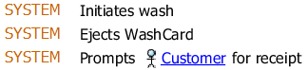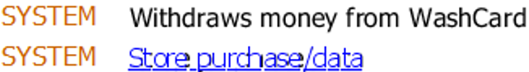

Wait for customer response

 does not want a receipt

Trigger event 6 trigger event 7

Event: 6

Trigger Event: 7

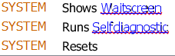

Event: 7



Wait for customer interaction

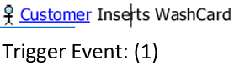

Event: 8



Trigger event: 7